**a. Preliminary Design:**

**·Password Re-transmit**

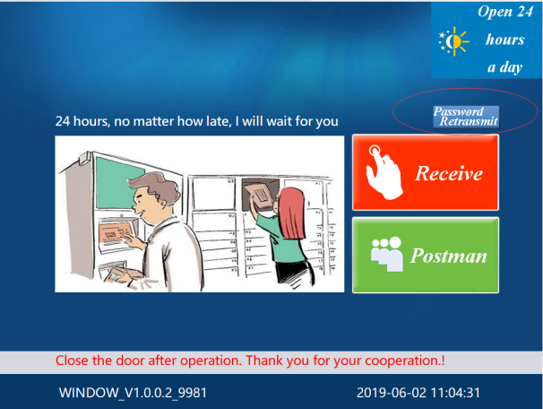 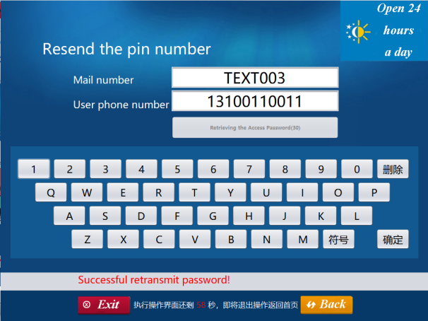

When the receiver needs to get the password again, click on the "Password Re-transmit" button on the main interface, and then enter the order information and the receiver's phone number.

**·Postman Retrieve**

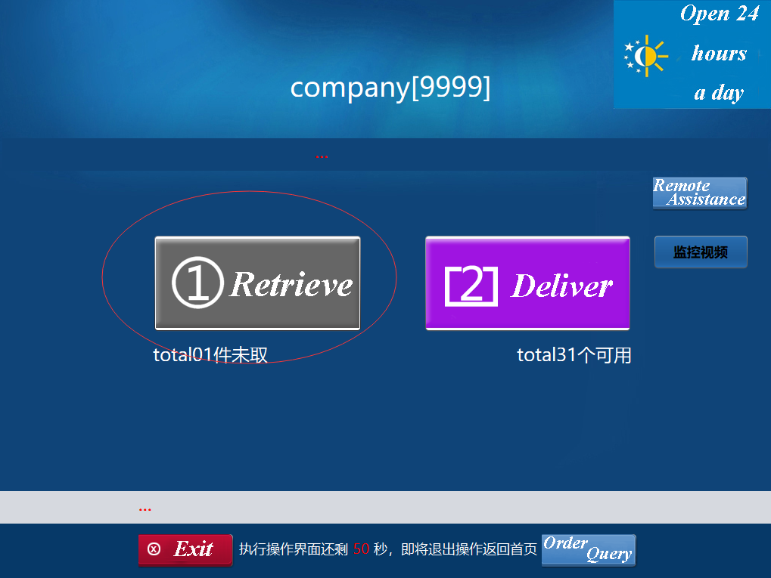 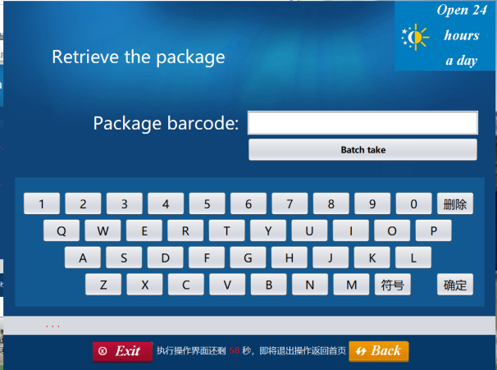

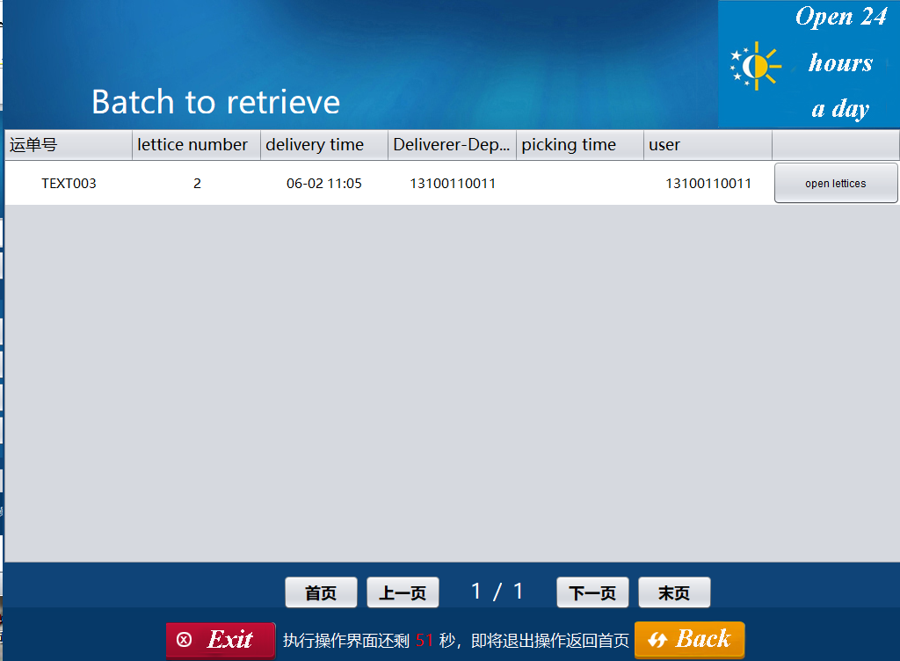 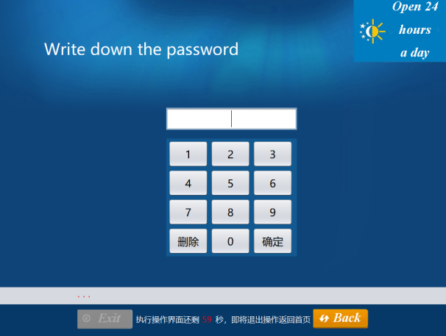

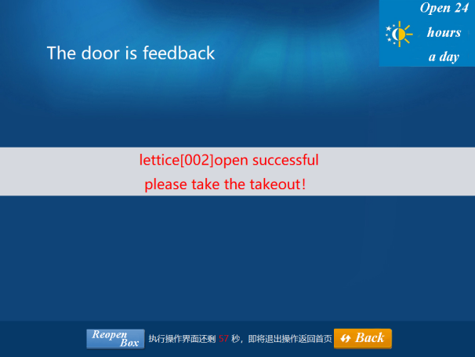

When the postman wants to retrieve the package, he clicks the "Retrieve" button, then enters the order number, selects the package to retrieve, and finally enters the password to submit.

**·Postman Order Query**

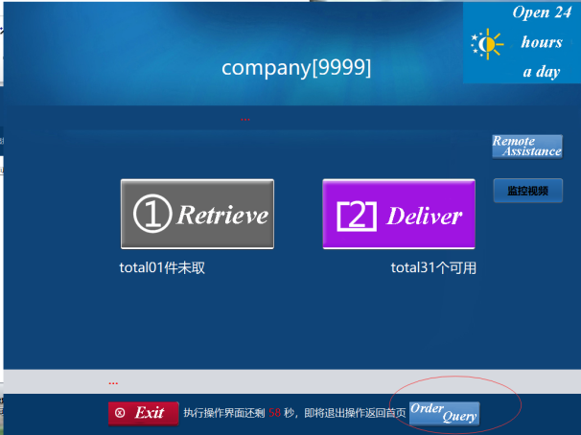 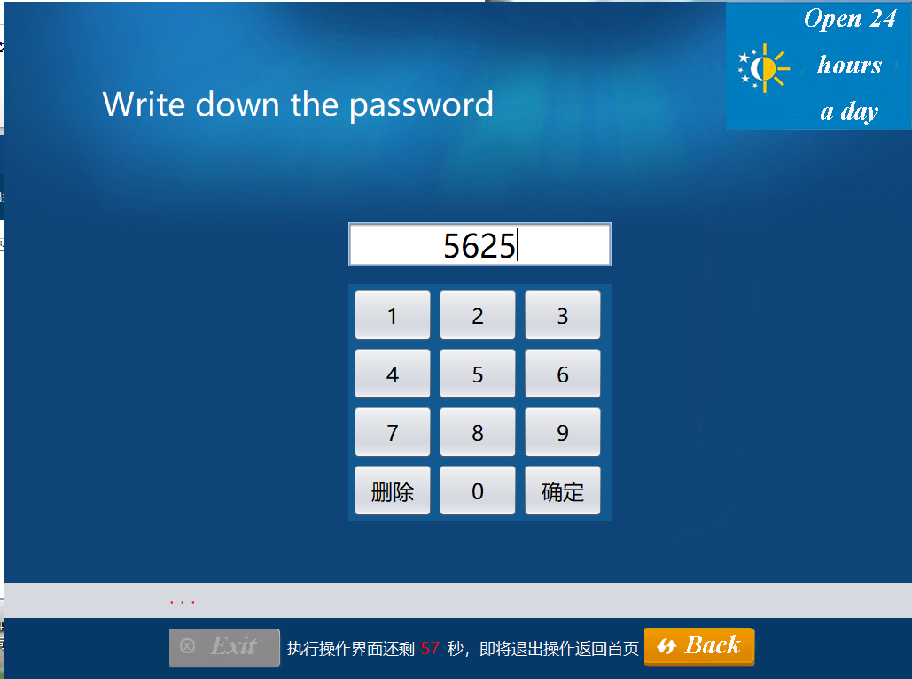

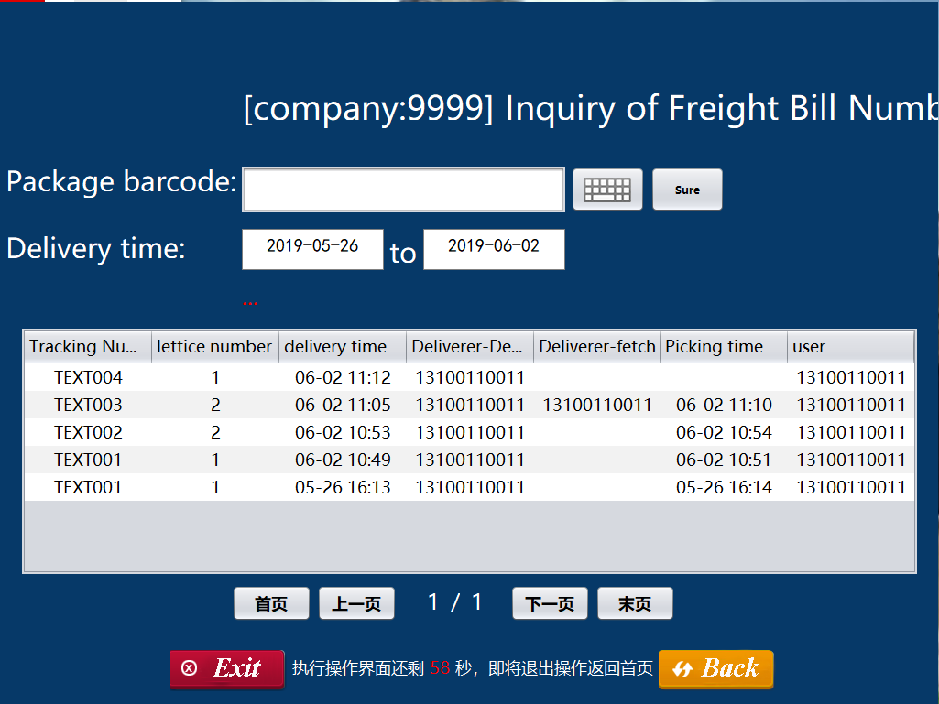

When a postman needs to inquire about his own delivery record, he clicks the "Order Query" button, he can browse all the records after entering his password. He can also enter an order number to search.

**·Re-select Cabinet**

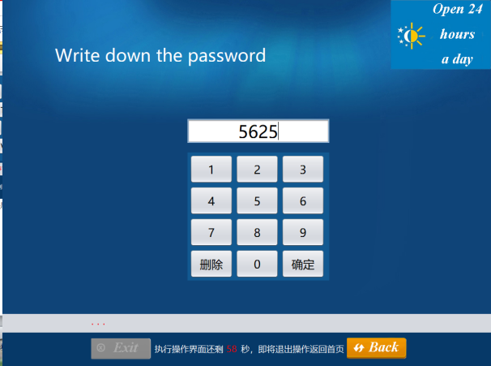 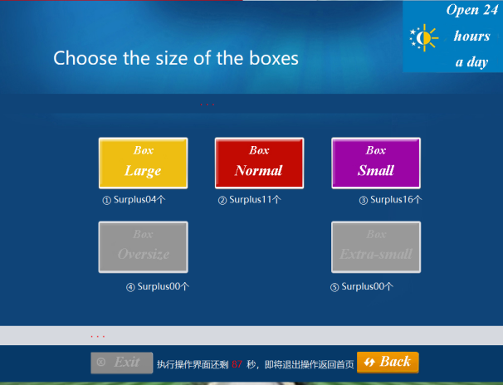

When the sender needs to re-select the cabinet, he needs to close the open cabinet, click the "Change the cabinet" button, and then select the cabinet he needs.

**·Receiver Order Query**

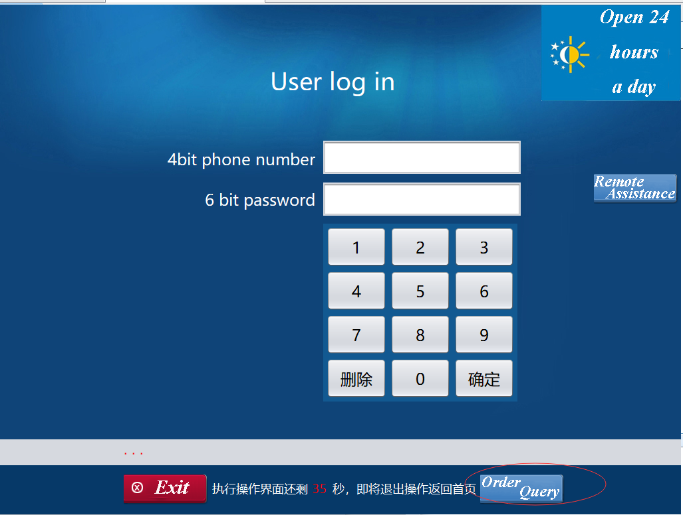 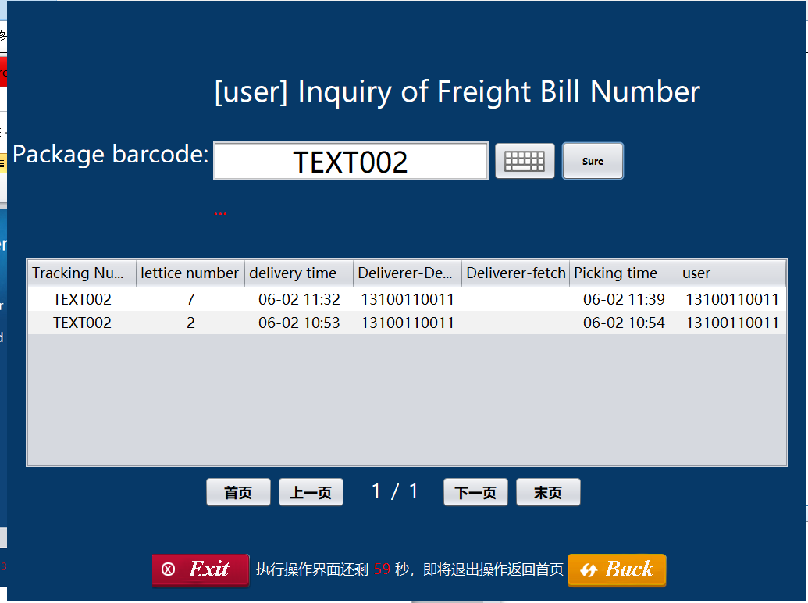

When a receiver needs to inquire about his own receive record, he clicks the "Order Query" button, he can browse all the records after entering his password. He can also enter an order number to search.

**b. User Effort Estimation:**

**·Password Re-transmit**

A total of 33 clicks on the screen, as follows

Click the "Password Re-transmit" button

Click the “Order number”input box

Click “x” “x” “x” “x” “x” “x” “x” “x”

Click the “Receiver’s phone number” input box

Click “x” “x” “x” “x” “x” “x” “x” “x” “x” “x” “x”

Click the "Confirm" button

**·Postman Retrieve**

A total of 18 clicks on the screen, as follows

Click the "Retrieve" button

Click the "Order number" input box

Click “x” “x” “x” “x” “x” “x” “x” “x”

Click the "Confirm" button

Click the "Open cabinet" button

Click the "Password" input box

Click “x” “x” “x” “x”

Click the "Confirm" button

**·Postman Order Query**

A total of 17 clicks on the screen, as follows

Click the "Order Query" button

Click the "Password" input box

Click “x” “x” “x” “x”

Click the "Confirm" button

Click the "Order number" input box

Click “x” “x” “x” “x” “x” “x” “x” “x”

Click the "Search" button

**·Re-select Cabinet**

A total of 8 clicks on the screen, as follows

Click the "Change the cabinet" button" button

Click the "Password" input box

Click “x” “x” “x” “x”

Click the "Confirm" button

Click the "Normal Box" button

**·Receiver Order Query**

A total of 17 clicks on the screen, as follows

Click the "Order Query" button

Click the "Password" input box

Click “x” “x” “x” “x”

Click the "Confirm" button

Click the "Order number" input box

Click “x” “x” “x” “x” “x” “x” “x” “x”

Click the "Search" button